# Building a plot layer by layer

* To create a plot object, we use the command ggplot().
* This command has two arguments

1. Data : the data frame you wish to visualize.
2. Aesthetic mapping

|  |
| --- |
| > P <- ggplot(mtcars, aes(mpg,wt,colour=factor(am)))  > |

* Nothing to see yet. We need to add some layers!
* (Try out the summary function on the object P)

# Adding Layers

* If we add a ***point*** ***geom***, we can create a scatter-plot

|  |
| --- |
| > P + geom_point()  > # alternatively: P + layer(geom="point") |

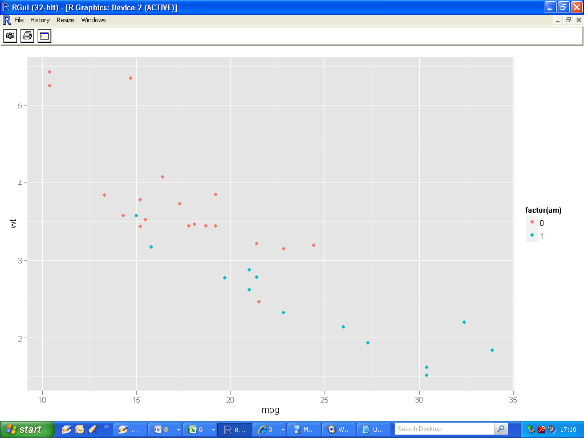

* We can add a smoothing line using the ***smooth geom.***

|  |
| --- |
| > P <- ggplot(mtcars, aes(mpg,wt))  > P + geom_point()+geom_smooth()  > |

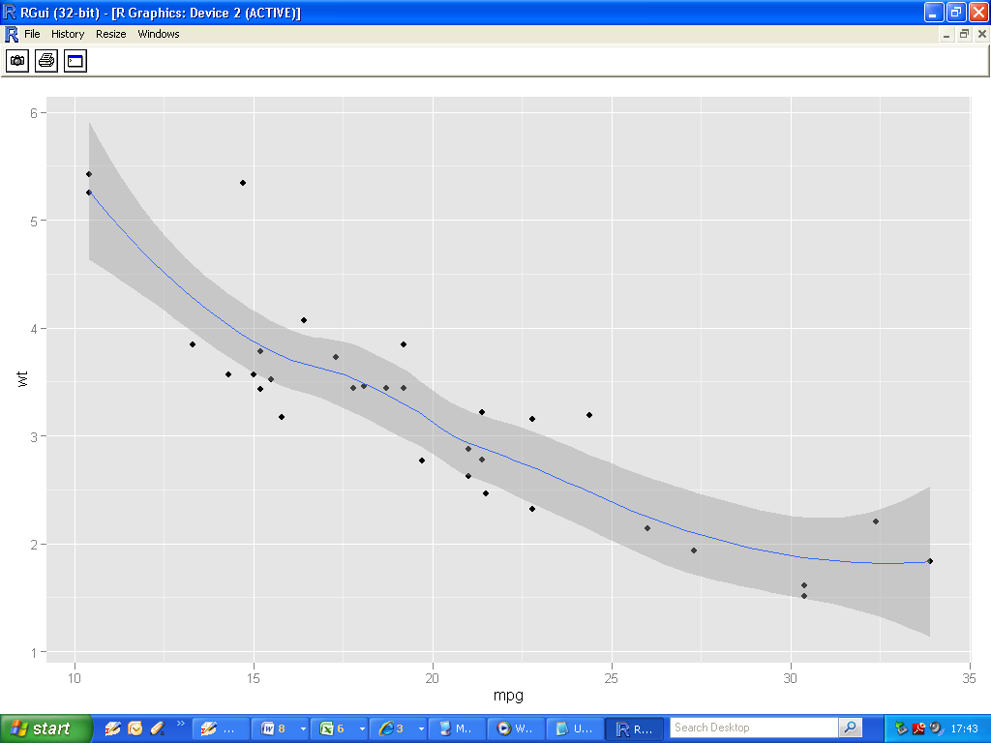

# Creating a simple histogram

* One (continuous) variable is specified in the ggplot() command.,
* (i.e. mpg as the x-variable).
* The appropriate geom is simply geom_histogram().

|  |
| --- |
| > H <- ggplot(mtcars, aes(mpg))  > H + geom_histogram() |

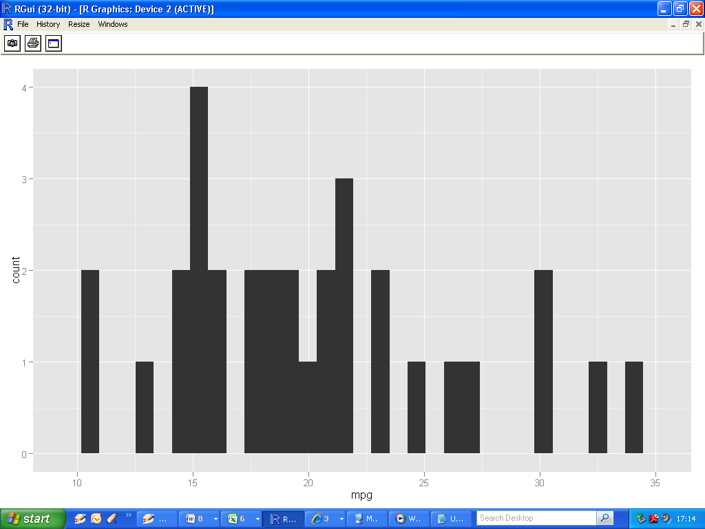

# Enhancing your histogram

* Simply adjust the relevant arguments in geom_histogram()
* We change the bin width to 2
* And the fill colour to steelblue

|  |
| --- |
| > H <- ggplot(mtcars, aes(mpg))  > H + geom_histogram(binwidth=2,fill="steelblue") |

